I had fun with this assignment. Especially the creative sources part. I feel like when you read something verses when you view something you may interpret a whole different visual of what the author/artist is trying to say. I’m a very visual person, so for me, the creative source (especially the picture I found) spoke volumes and gave me the goosebumps.
The purpose of my paper is to share reasons as to why arranged/forced marriages need to be stopped.
The problem with arranged/forced marriages is that they violate many woman and children’s rights. The data source that I found that supports that arranged/forced marriages are a problem is listed below. This organization provides many statistics and reasons as to why child marriage is violation of human rights. They provide excellent information such as how many women were married by certain ages and how many of those women had a choice in their husband. The information is gathered through that national censuses and national household surveys, mainly through the multiple indicator cluster surveys (MICS) and demographic and health surveys (DHS). These statistics will be provided great evidence into my paper by sharing just how many women really do not have a say in who they marry.
The creative source I was able to find is a picture of a young women burning. In many arranged marriages there are dowry deaths. Dowry deaths include things like bride burnings which means literally burning the bride to the point of serve burns or death. I think this image would help give people an idea of just how inhuman arranged marriages are. Many people do not think of what comes along with arranged marriages and are truly shocked when they realize families in arranged marriages commit hateful crimes such as bride burnings. Not only will making stronger and better laws end arranged marriages. It will also end the horrific acts of bride burning.
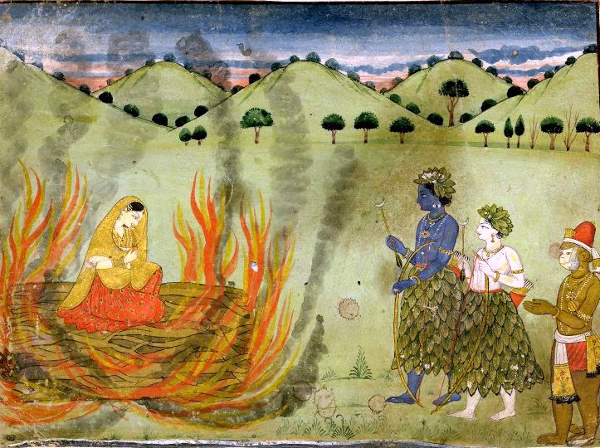
(Rāma, Lakṣmaṇa and Hanuman, n.d.).

References:
Jayanthan, T. K., (n.d.). Bride burning. Retrieved fromhttps://sites.google.com/site/tkjayanthan/home/bride-burning
UNICEF. (2018). Child marriage. Child Marriage is a Violation of Human Rights, but is all too Common. Retrieved from: https://data.unicef.org/topic/child-protection/child-marriage/

P.S. I hope I referenced this correctly. The picture was presented on Jayanthan’s website. However, the picture was created by Rama, Laksmana, and Hanuman. When I looked at Keys for Writers it stated about butting the person who actually did it in the in-text citations and putting the name of the person who I got the information from in the references. Can anyone let me know if I did it correctly?
Thanks in advance.

